CI

GitHub

+

Jenkins

+

Maven

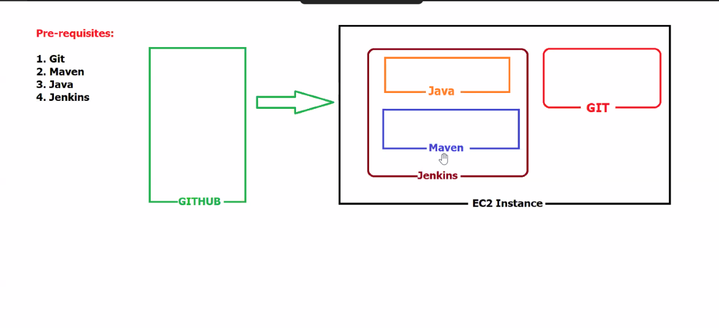

ON EC2 instance

Install

JAVA 1

amazon-linux-extras java-oprnjdk11 -y

This 2 thing is very important

Install Jenkins with

Add Jenkins repo. to our YUM repo:

sudo wget -O /etc/yum.repos.d/jenkins.repo https://pkg.jenkins.io/redhatstable/jenkins.repo

Import a key-file from Jenkins-CI to enable the installation from package:

sudo rpm --import <https://pkg.jenkins.io/redhat-stable/jenkins.io-2023.key>

Install jenkins with:

Yum install jenkins -y

Access it from browser with defualt port 8080:



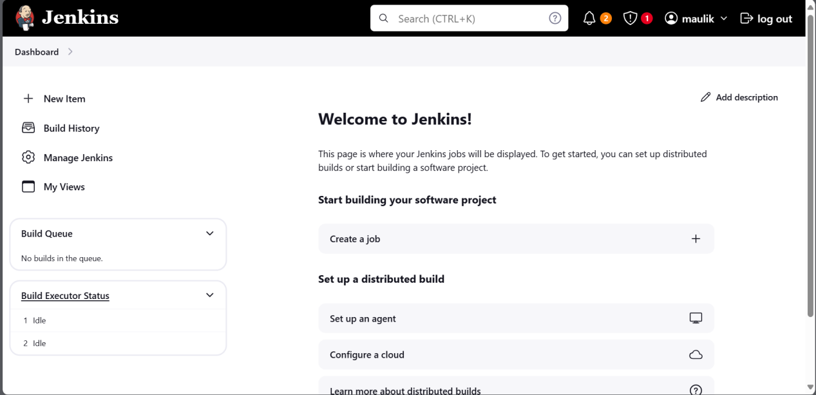

On jerkins we have to configure Maven and java



To do this follow the path

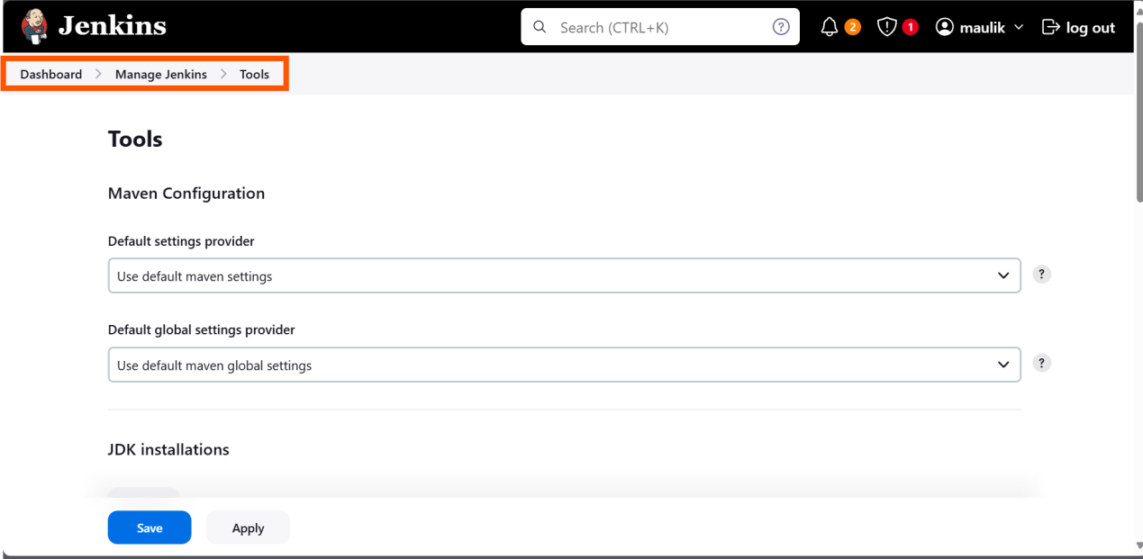

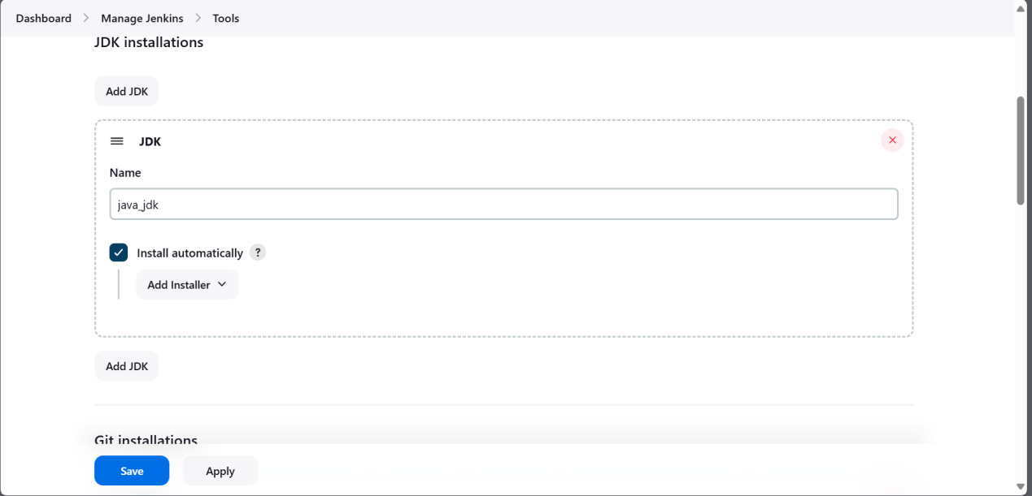

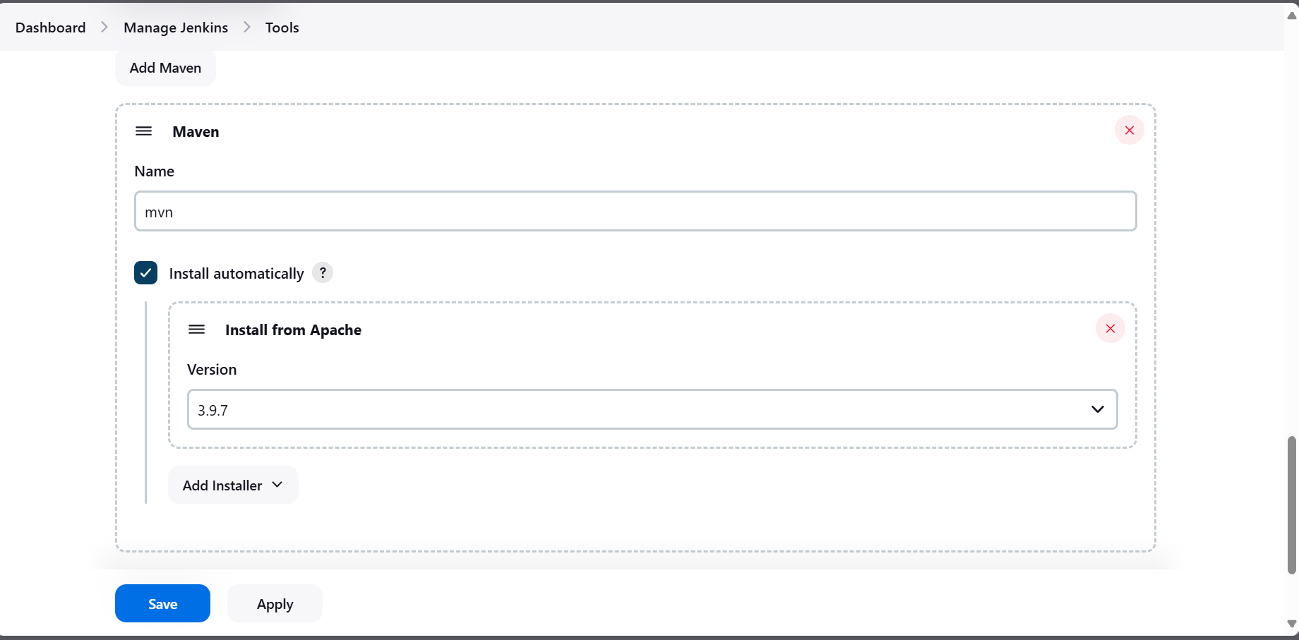

Now we are good to create project one

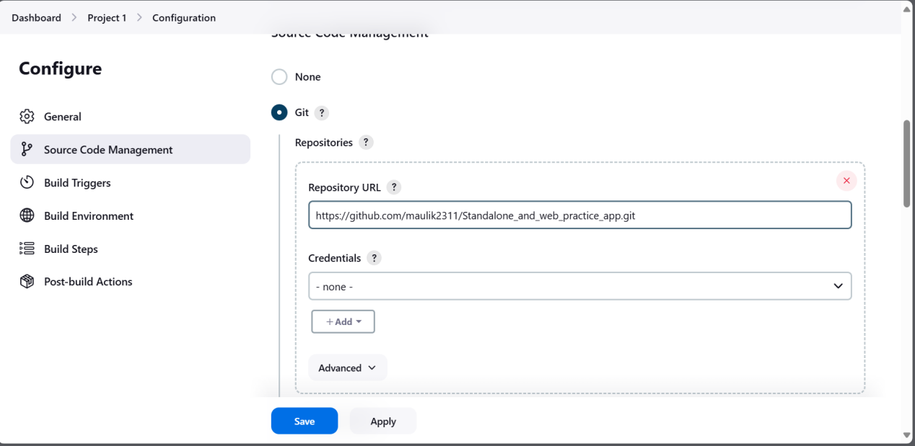

Now we need to comiple and pacakge code with maven, For that only we add maven in jenkins

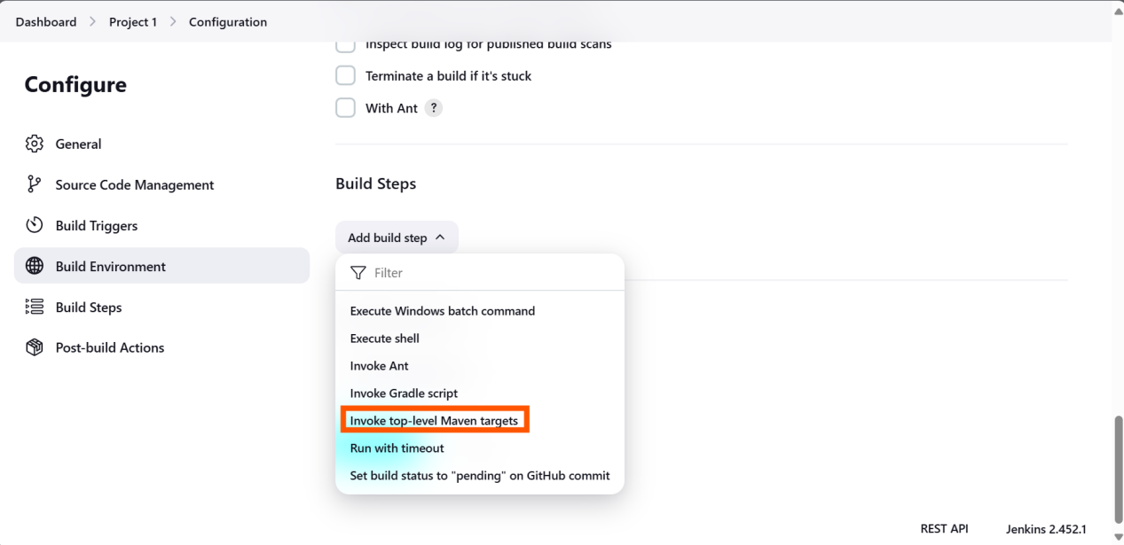

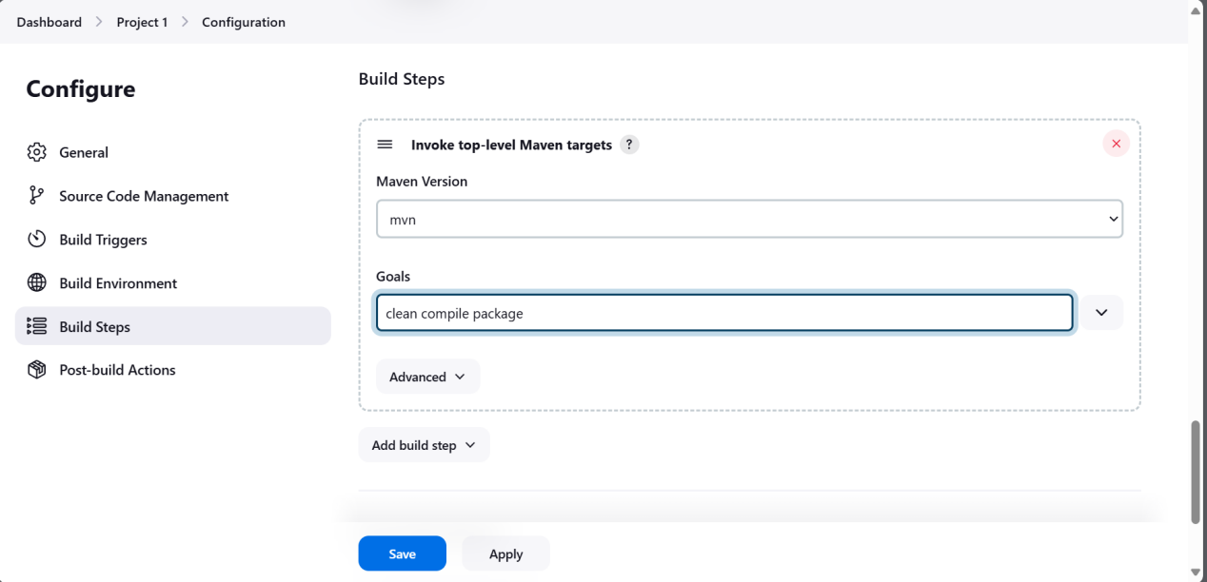

Build fail:::: How to know what is the problem?? --> click on #1 and check consule output that have all information

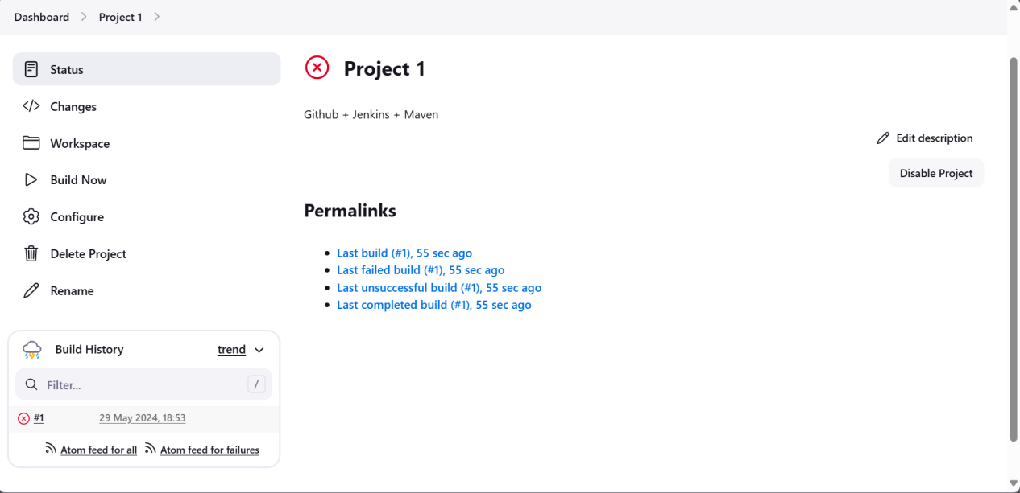

There is no POM file on path

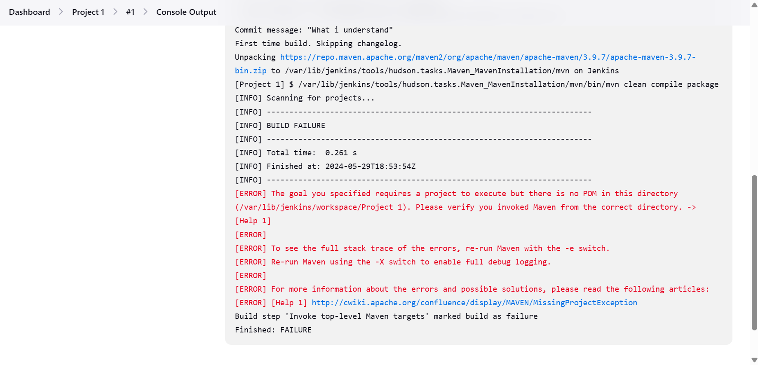

Lets try with proper path.

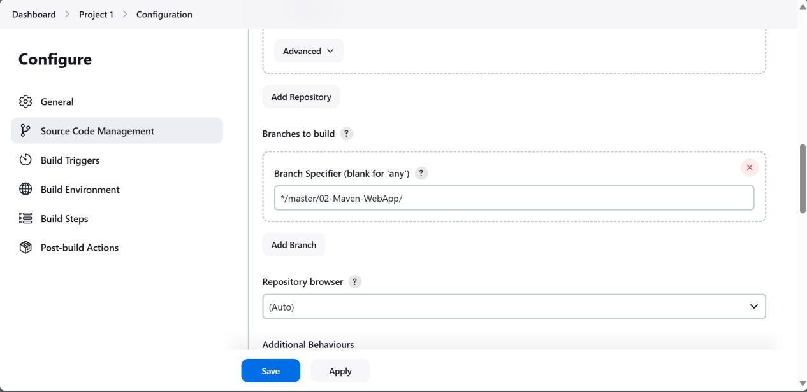

Total number of fail build 3:

Build Fail 1: no pom directory

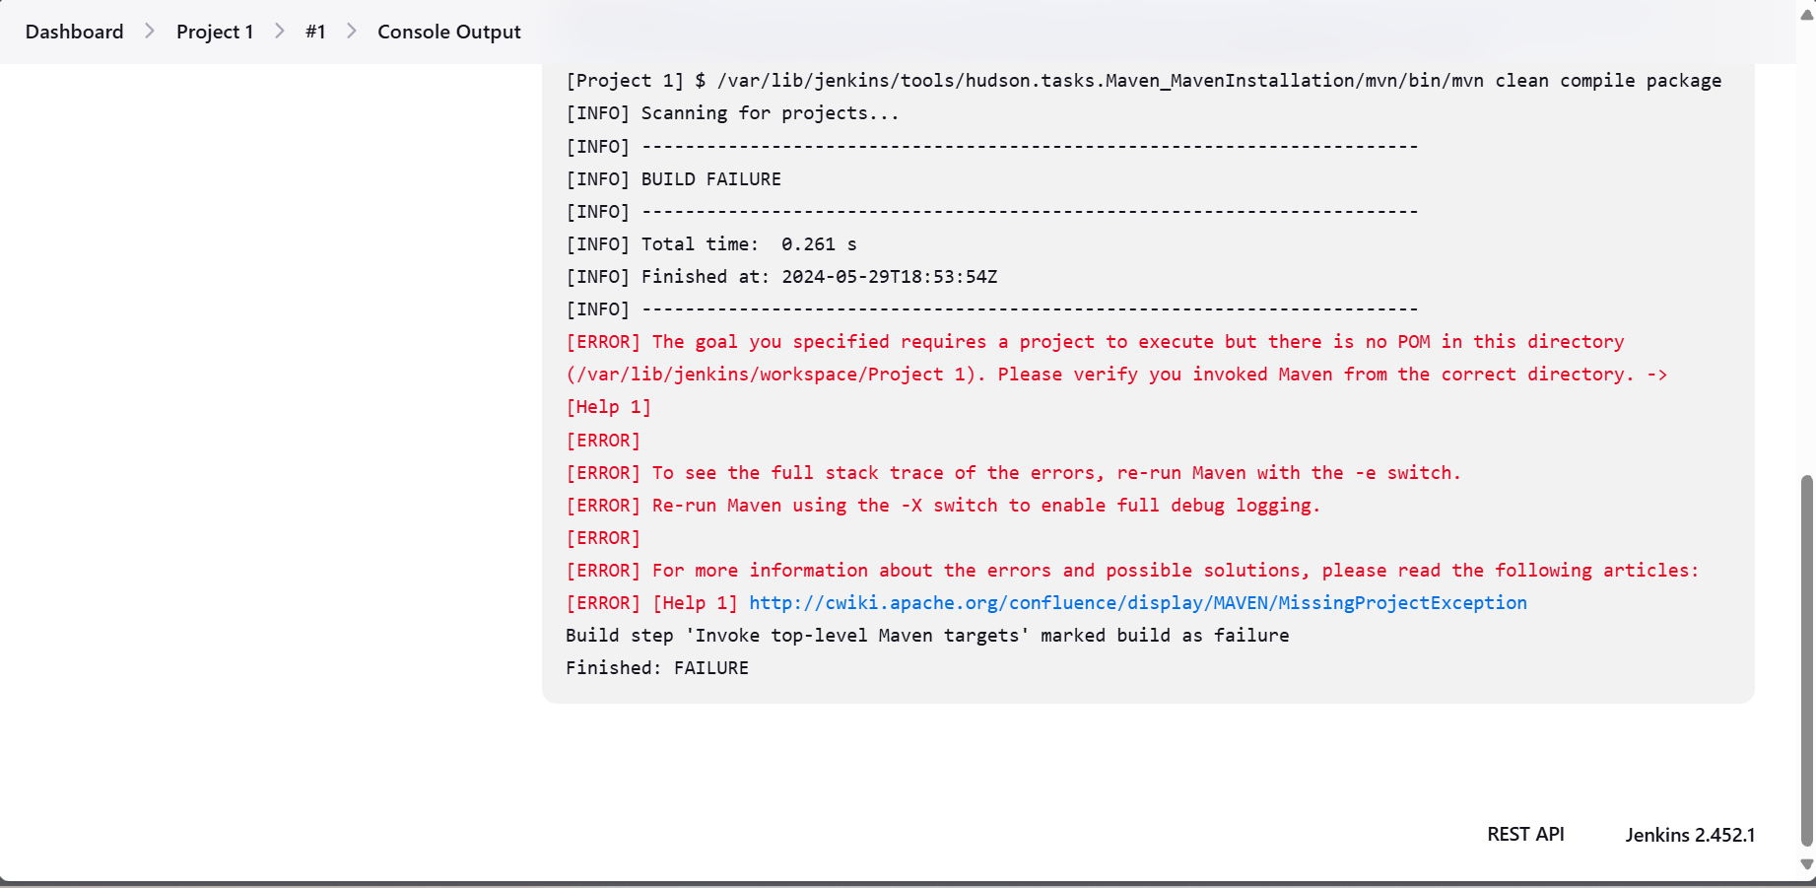

Try to solve

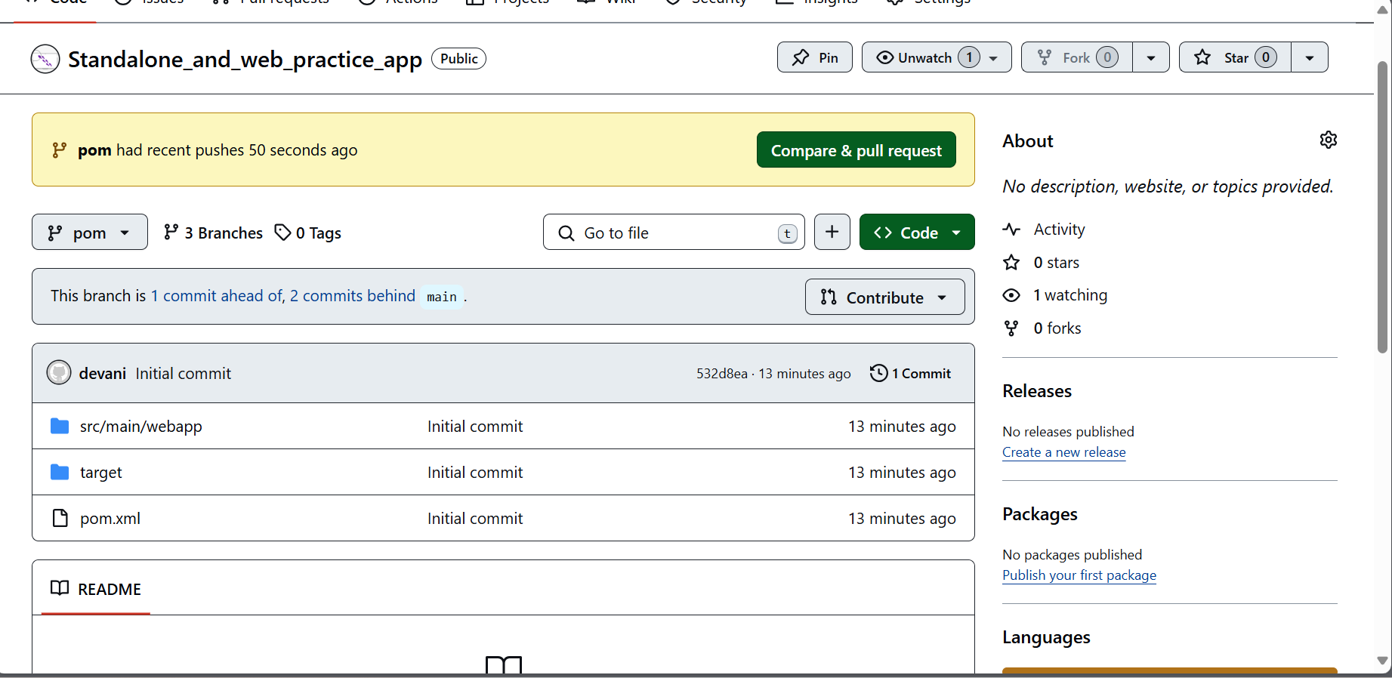

Build Fail2:

Not able to understand what is the problem

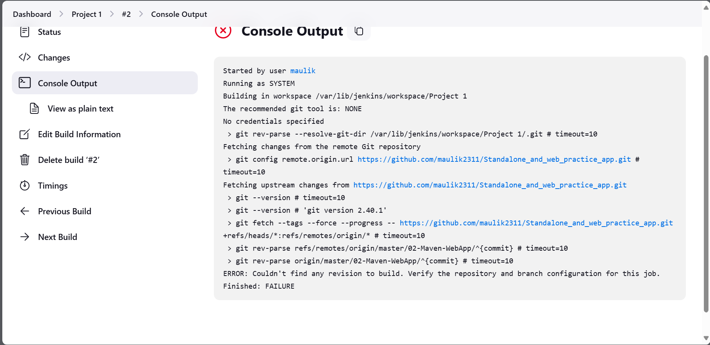

Build Fail #3:

Slowly understand what is the problem

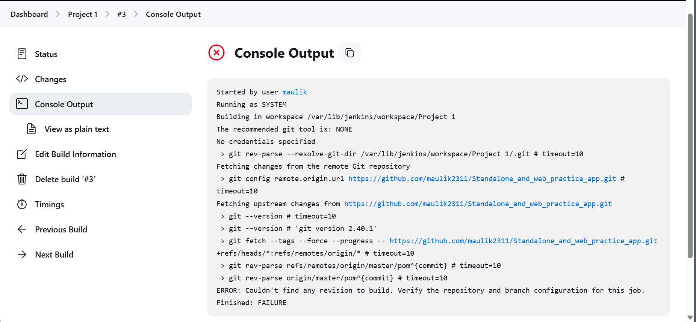

Build #4: Successes

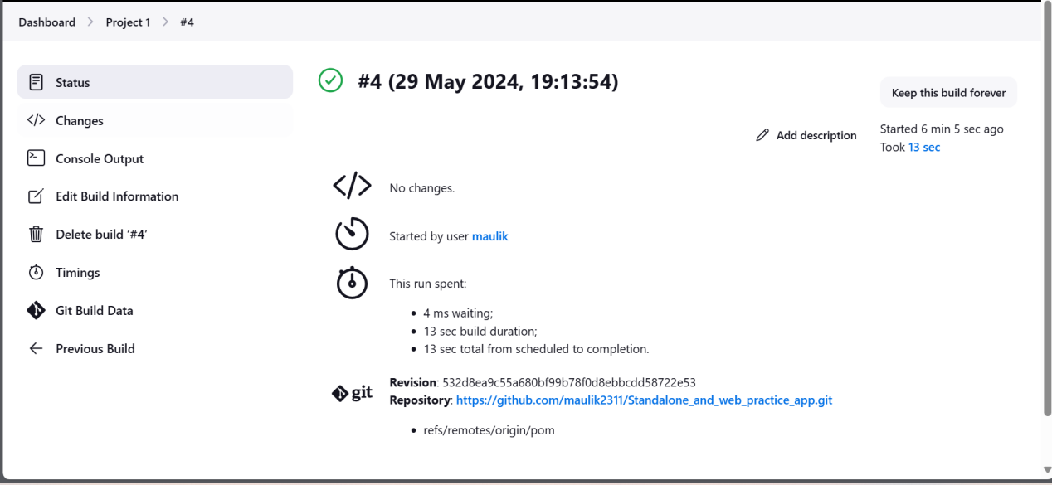

Problem that occur:

Path of repo

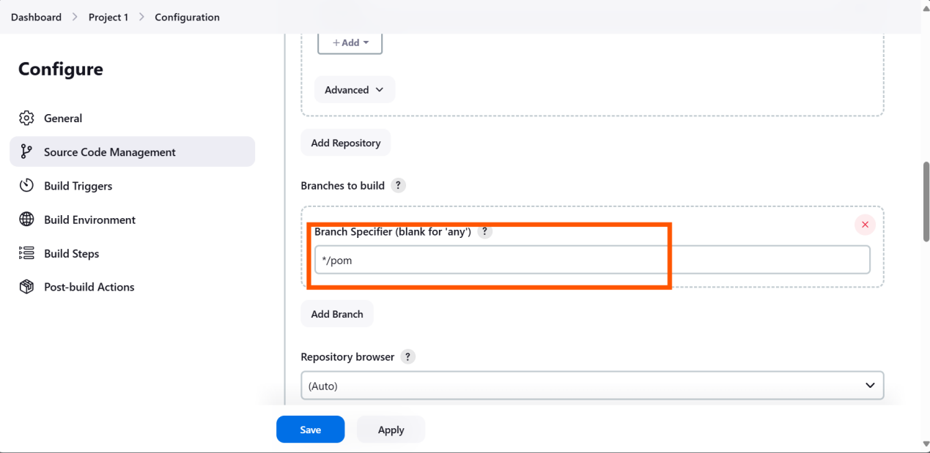

Project 2:

Continue Deployment

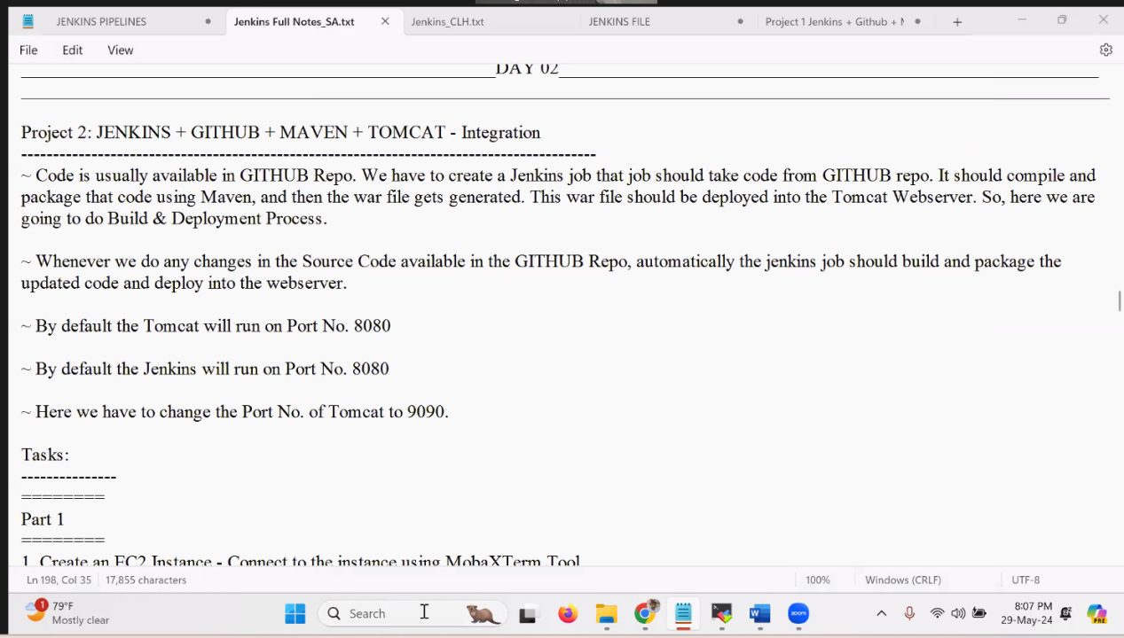

Architecture diagram:

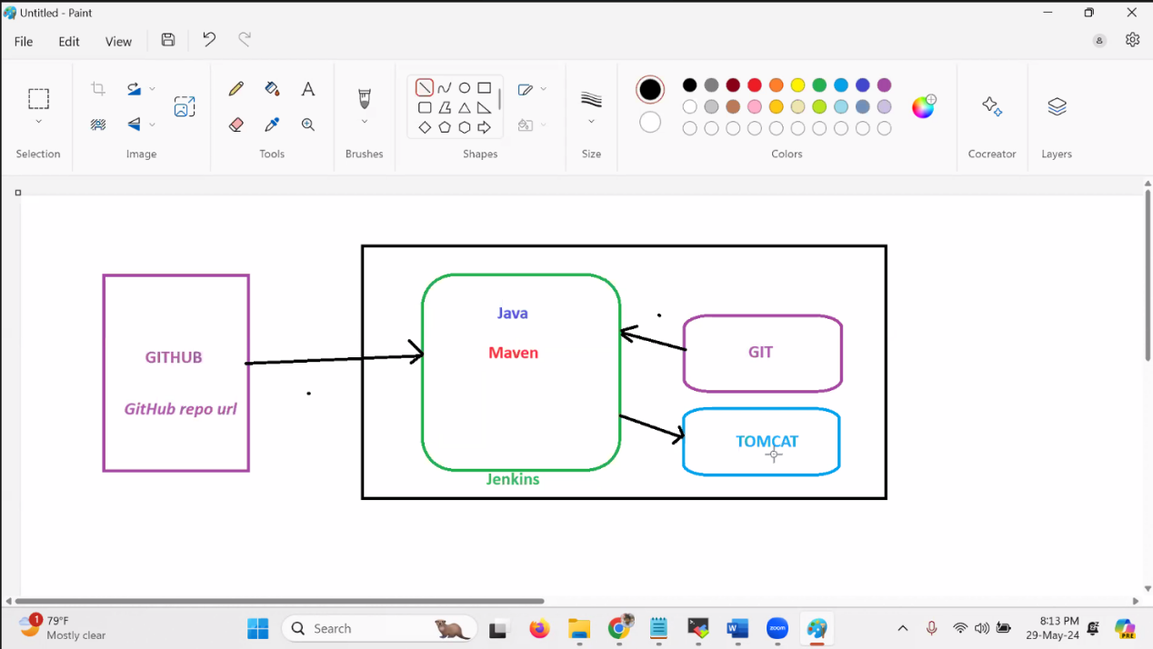

Already done: Jenkins server on it ---> java and maven

Git installed

Git Hub is attached with Jenkis

To Do: install apache tomcat on ec2 configure it for automation(Deploymeny)

APACHE TOM CAT CONFIGURATION:

Install apache tom-cat server:

Unzip the package and configure it:

/root/apache-tomcat-9.0.89/webapps/manager/META-INF

1. From [root@ip-172-31-20-1 apache-tomcat-9.0.89]# cd webapps/manager/META-INF

“Context.xml “

Edit with allow = “.*”

This will allow traffic from anywhere



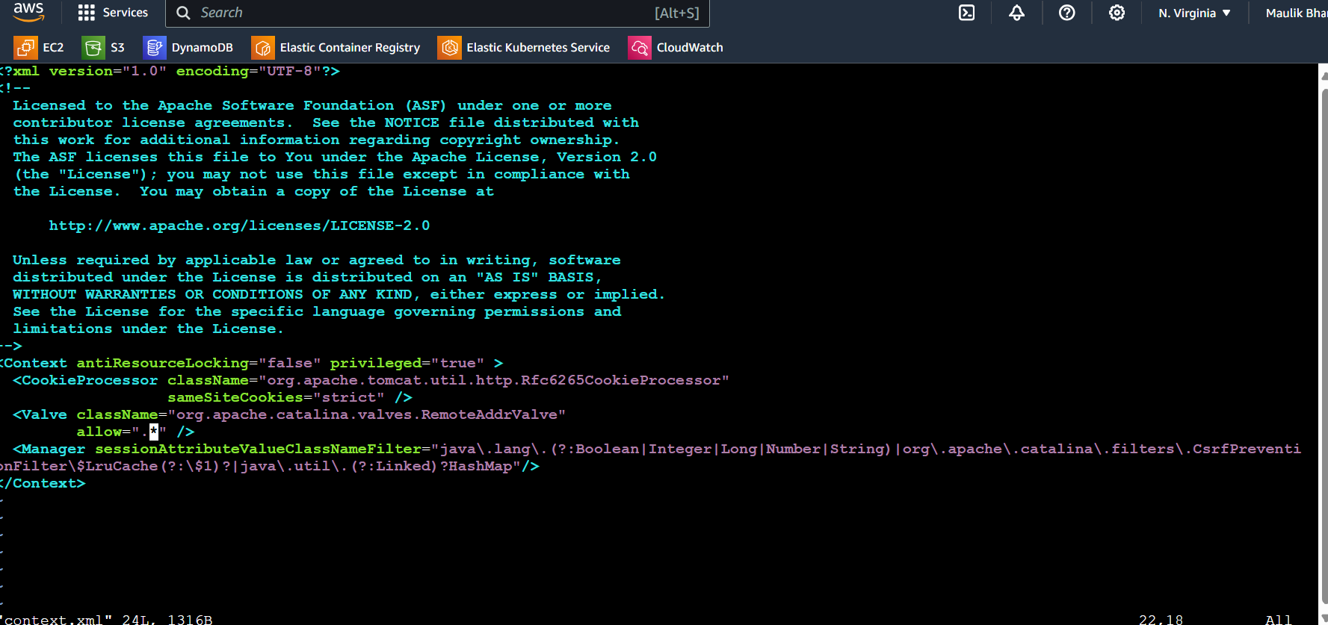

1. **For admin user interface this will allow to automate the automate deployment**

Add In tomcat-user.xml ============> This provide the admin access

<role rolename="manager-gui" />

<user username="tomcat" password="tomcat" roles="manager-gui" />

<role rolename="admin-gui" />

<role rolename="manager-gui" />

<user username="admin" password="admin" roles="manager-gui,admin-gui", "manager-script" />



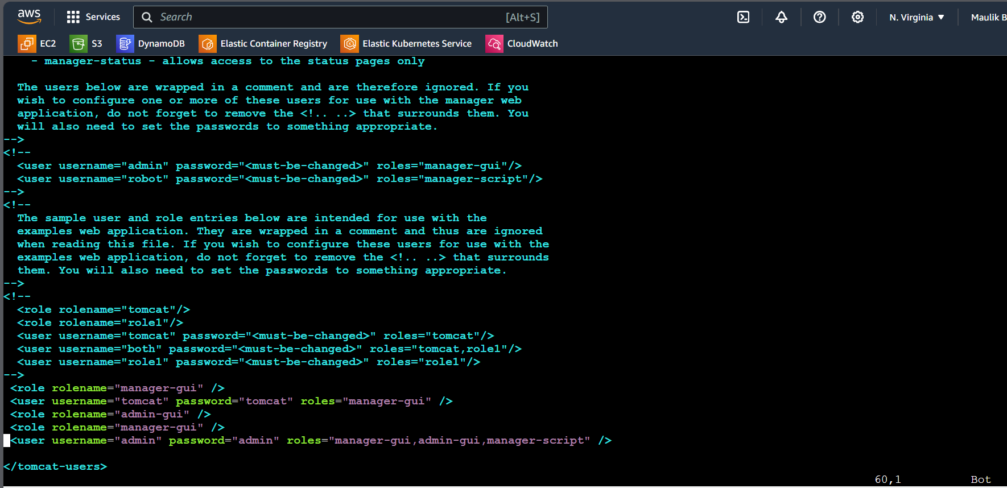

1. Tomcat and Jenkins work on same port

For that change port of tomcat for access it

How?

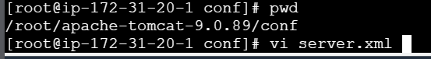

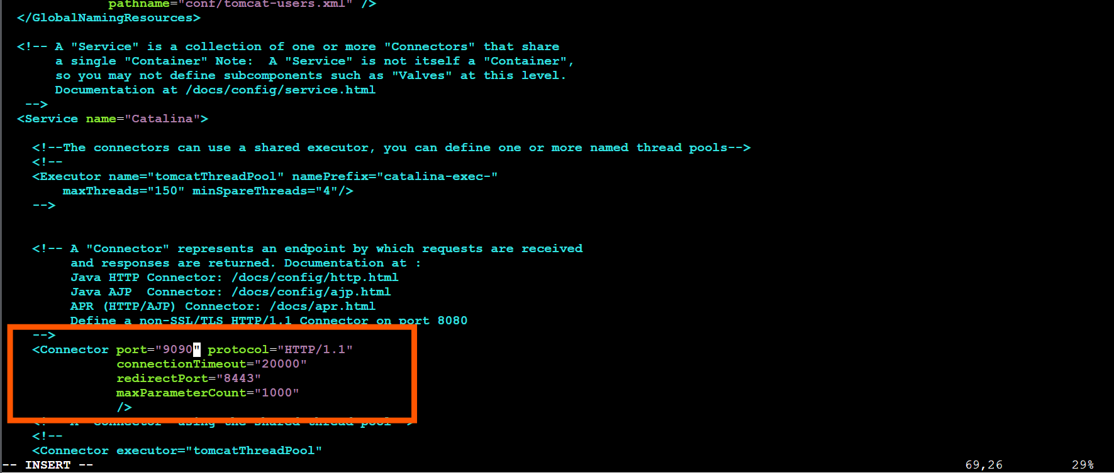

Try to access it

**Do not forget to allow the port from security group of server**

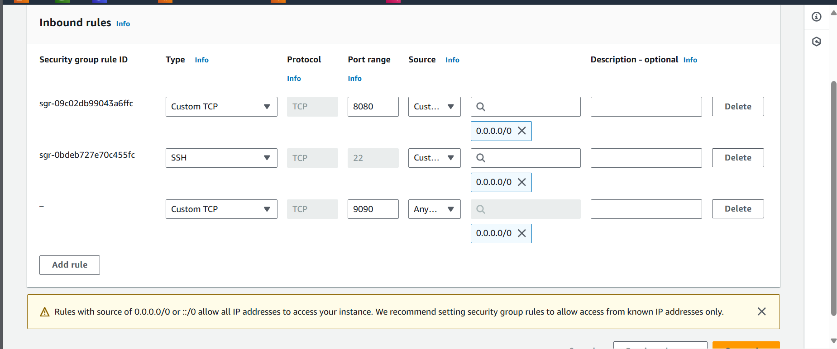

Access it with public ip with 9090 port

<publicip>:9090

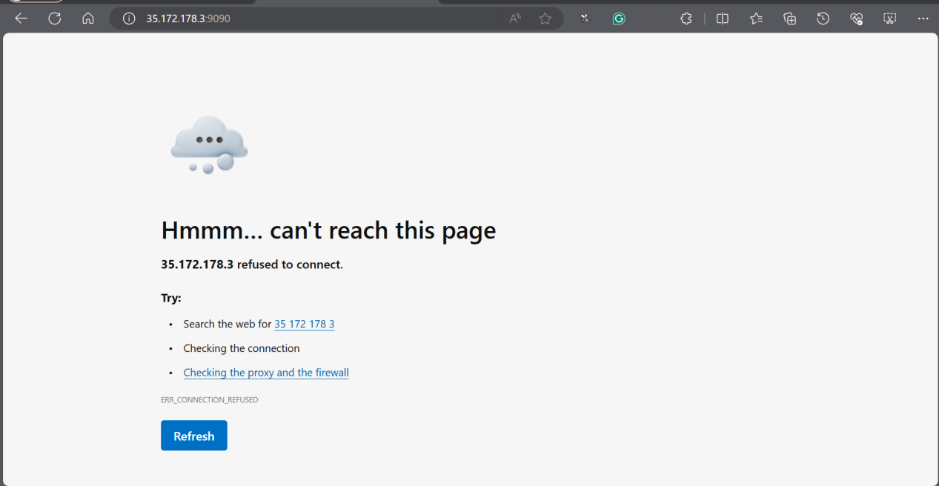

Why? --> Need to start Tomcat server from /bin folder

Need to start Tomcat server from /bin folder

Need to start Tomcat server from /bin folder

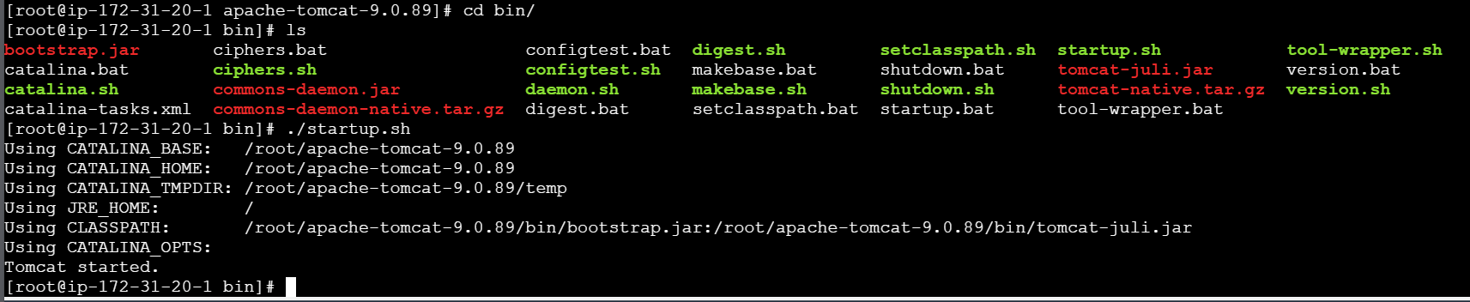

Allgood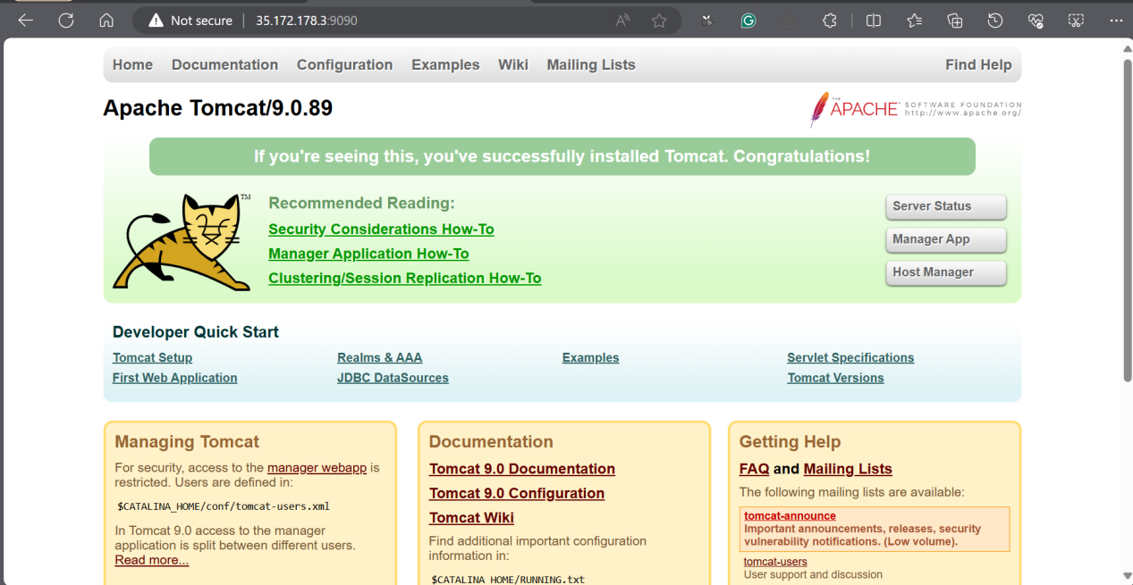

**NOTE: Still not able to access with admin password?**

**Shutdown.sh ----> startup.sh**

**This will work**

ON jenkins:

This plugin will deploy the .web to the tom cat server.

Add this plug in

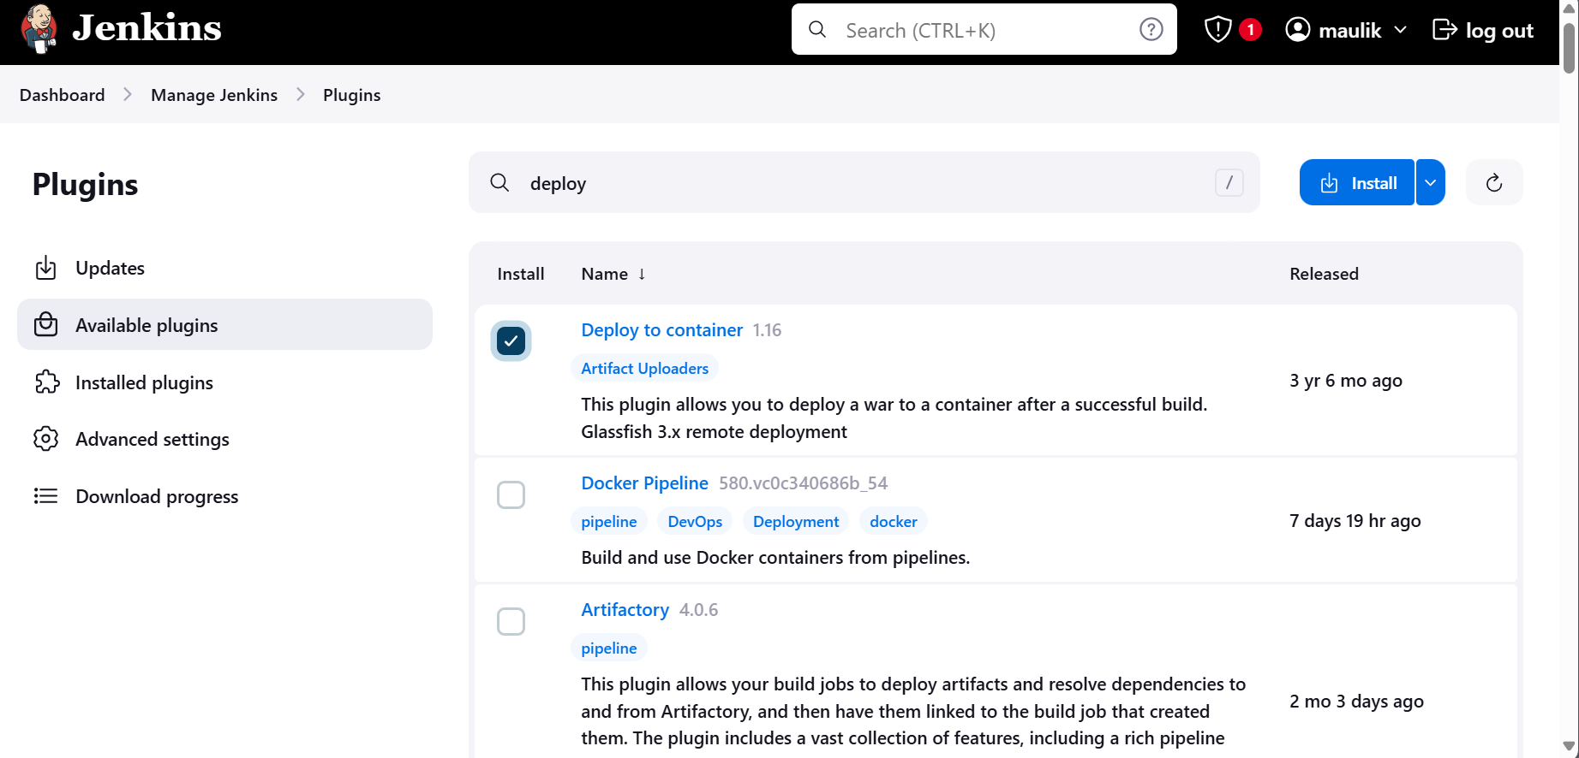

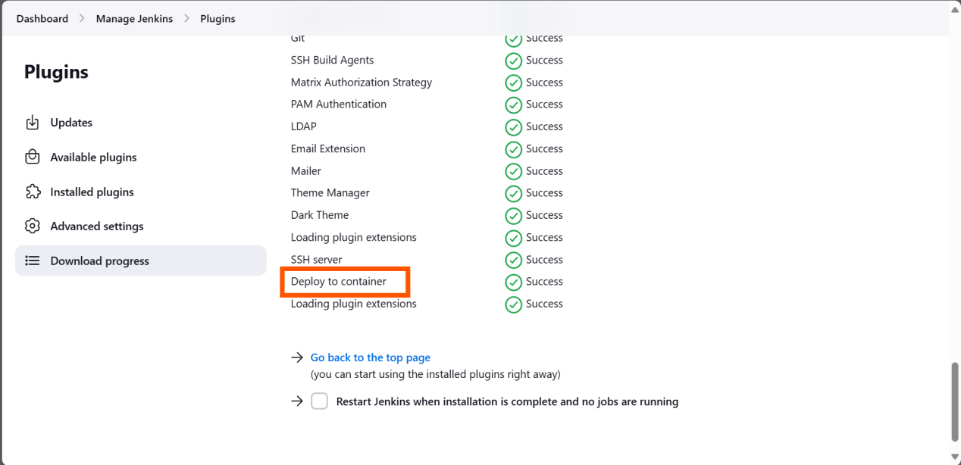

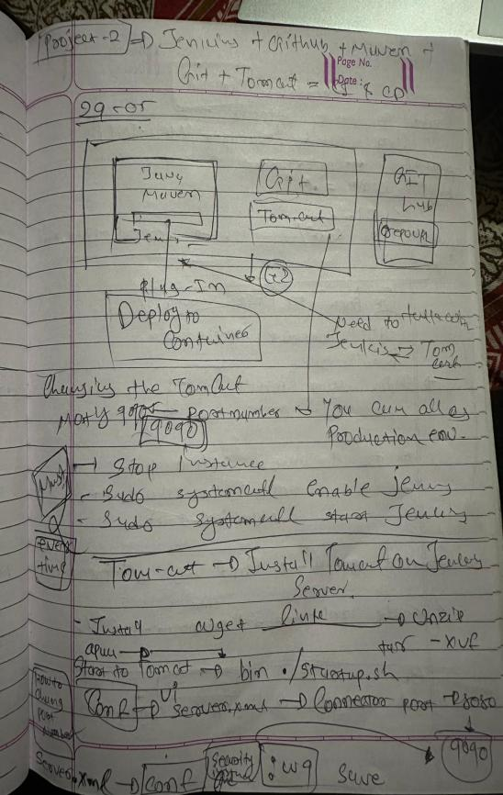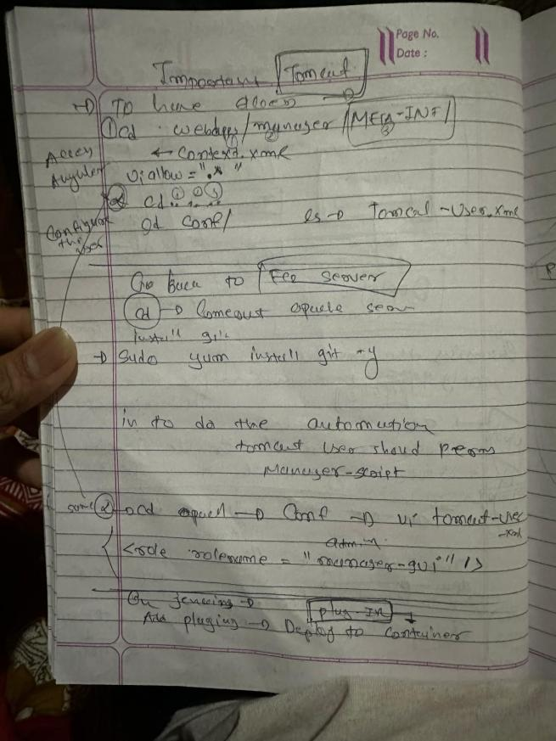

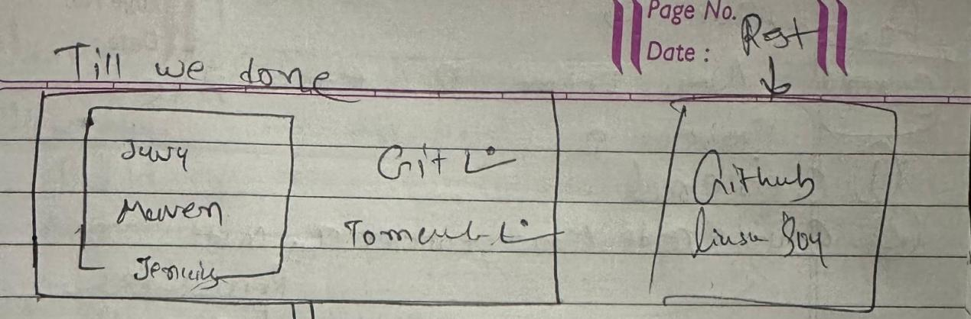

Till here we done.

Create a new job and configure git:

As already configure java and mvn(Manage je.--> tools) in project one I don have to do that again

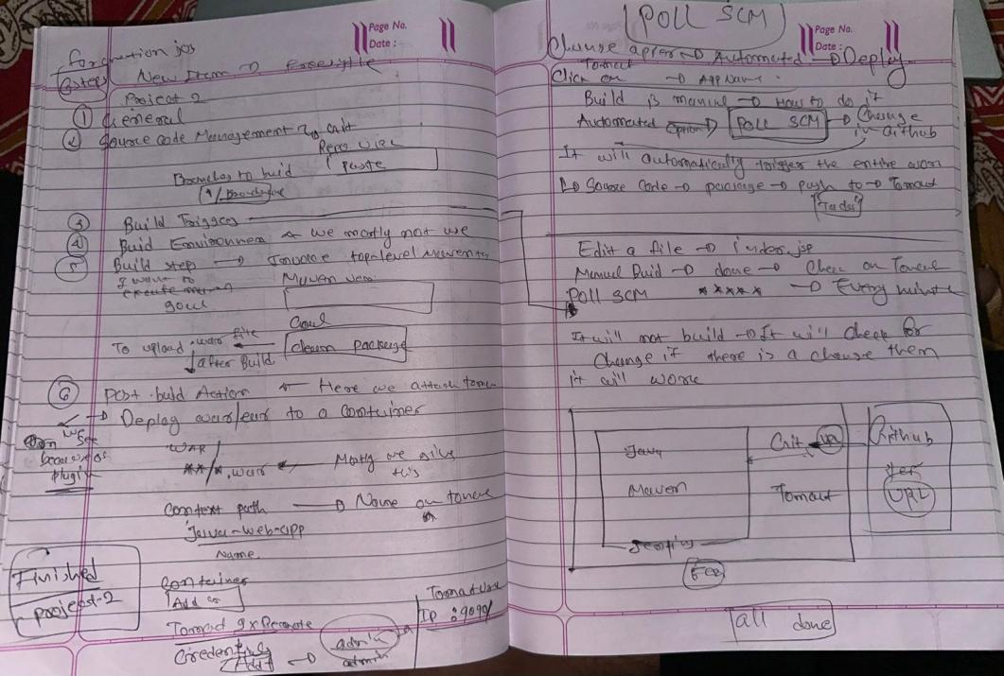

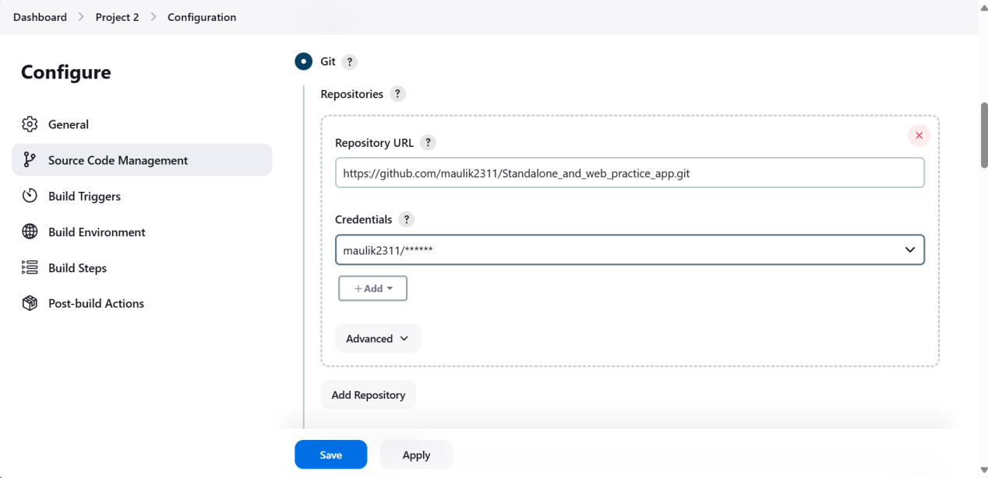

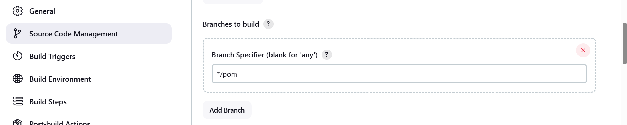

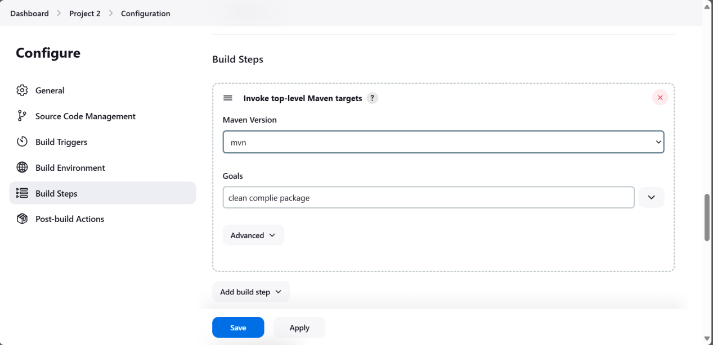

After build

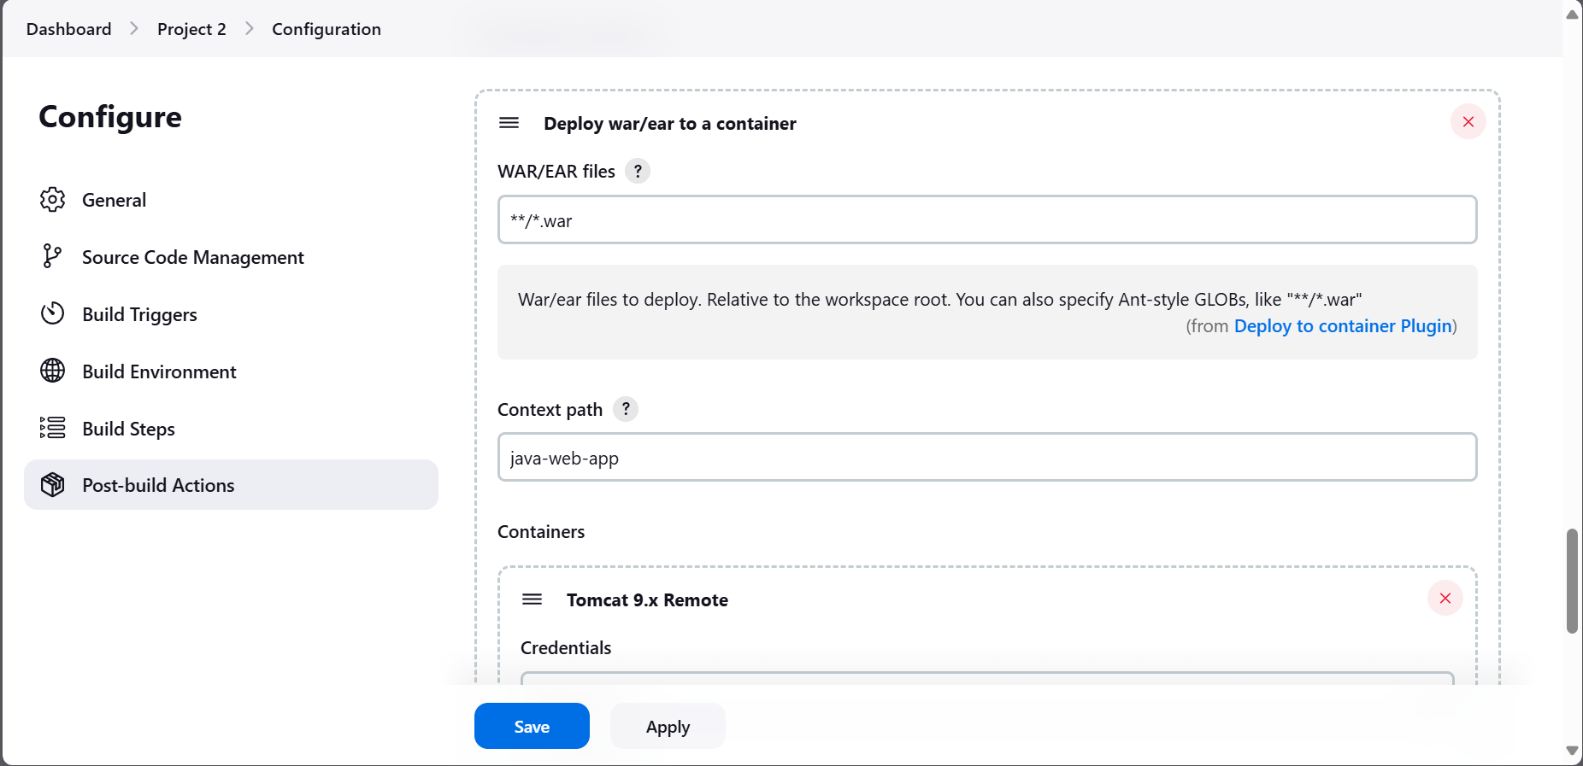

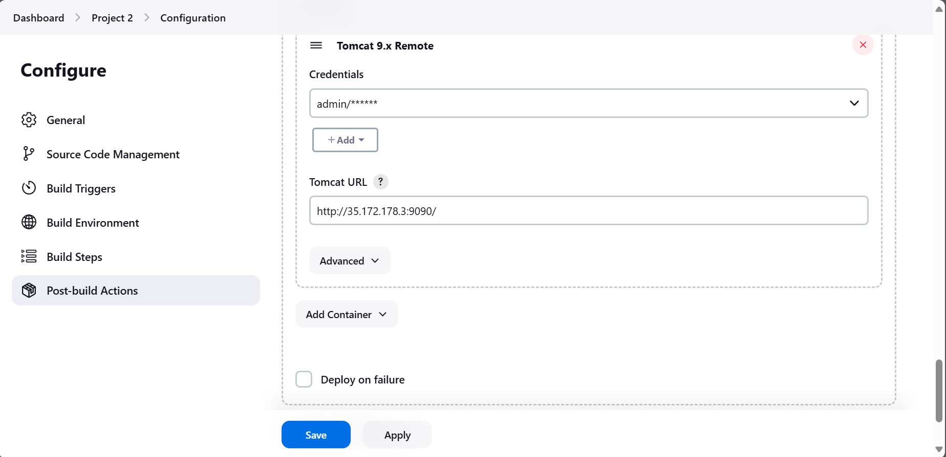

Build fail #1:

Spelling mistake

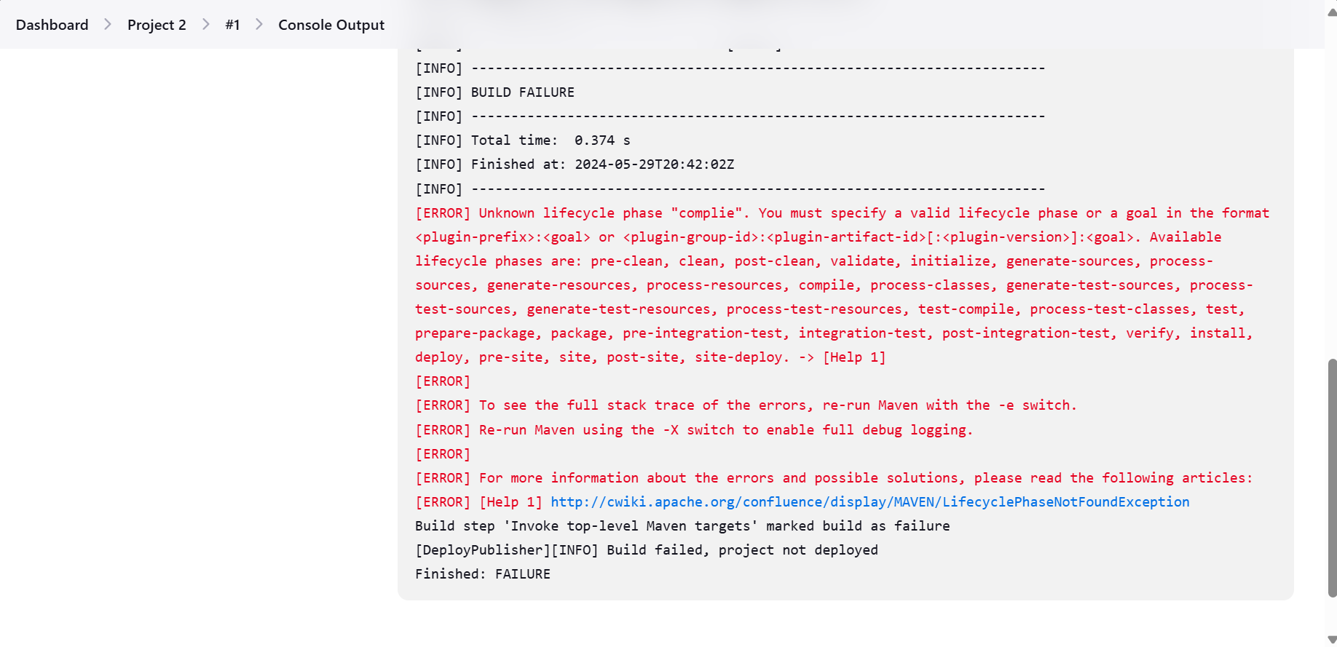

Build 2: Success

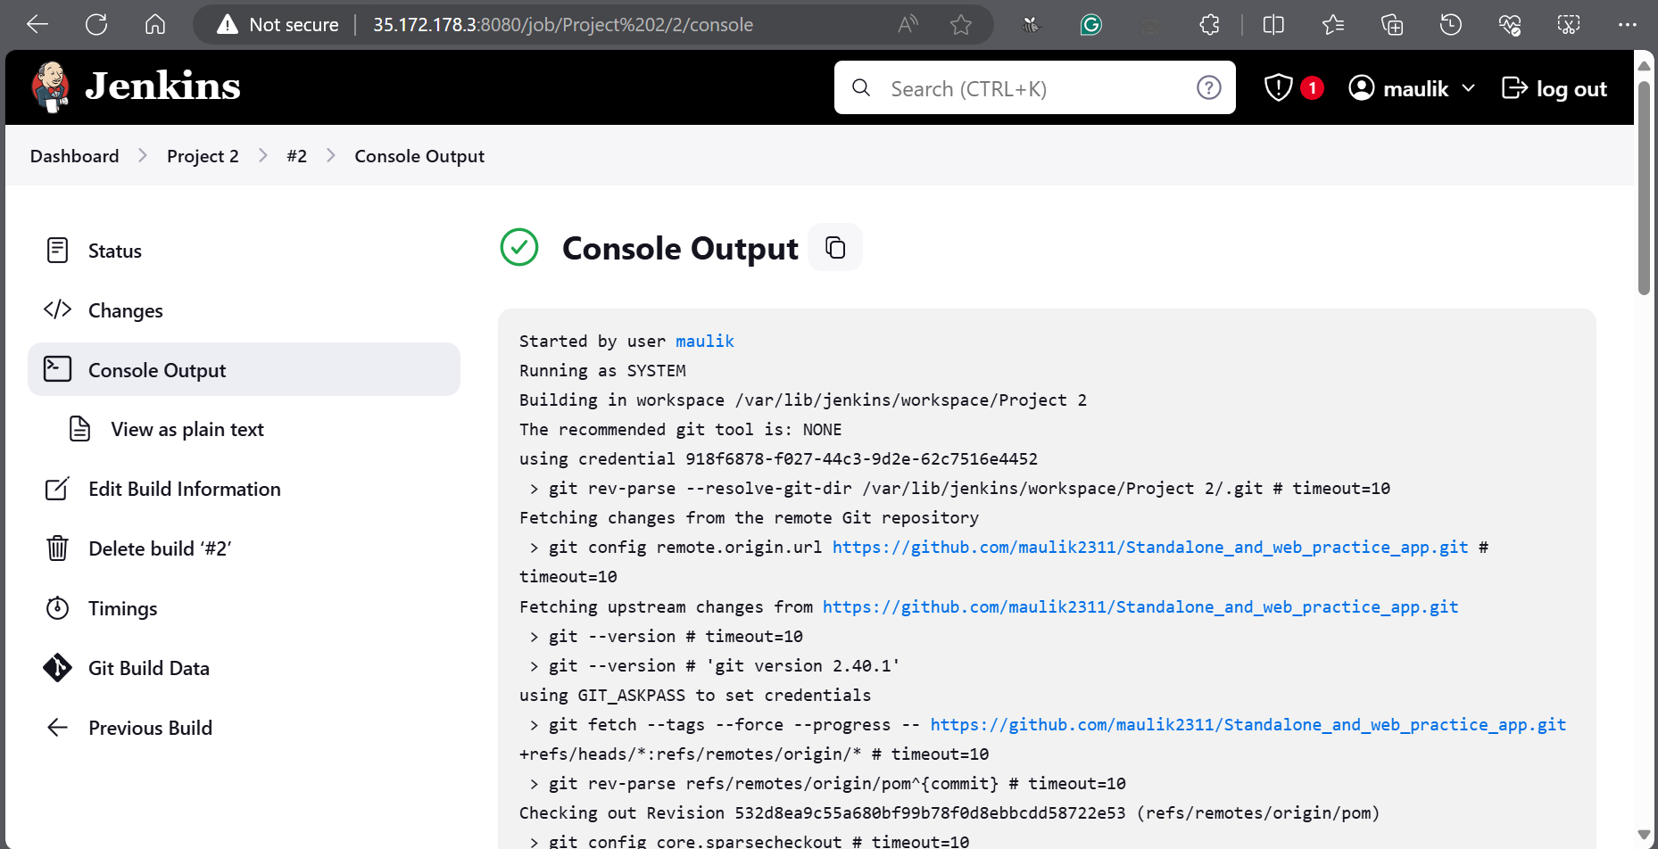

Deployment successful:

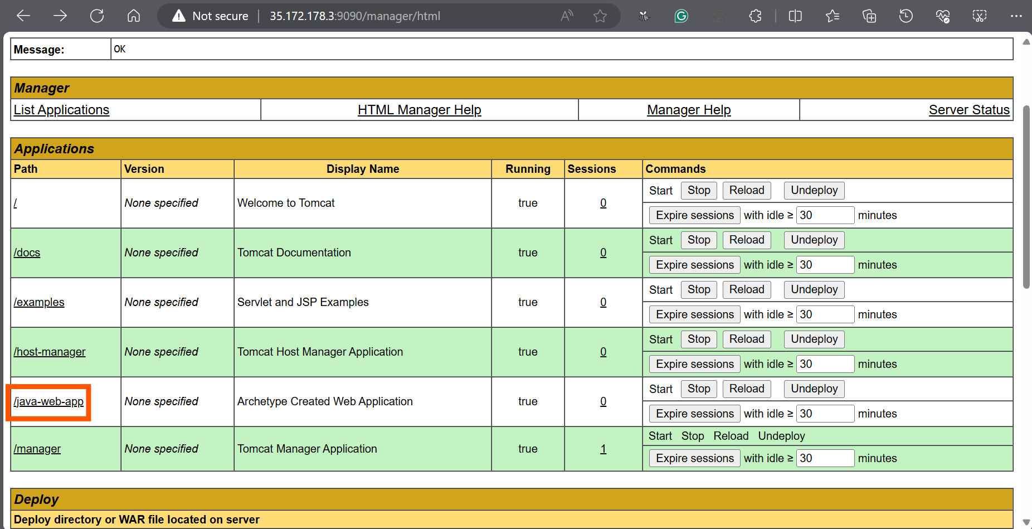

Checking app:

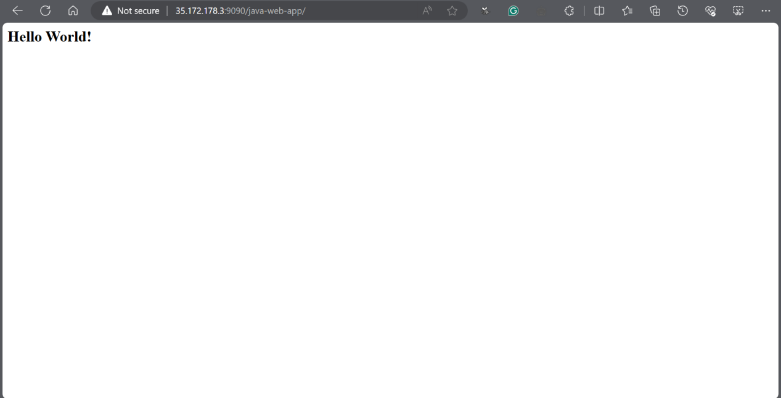

Project Done!!

**POLL SCM**

**Build Trigger ----> Poll SCM**: This will check code change in every minute if there is a change it will

Build the code automatically if build will success, Automatically it will upload on Tomcat server

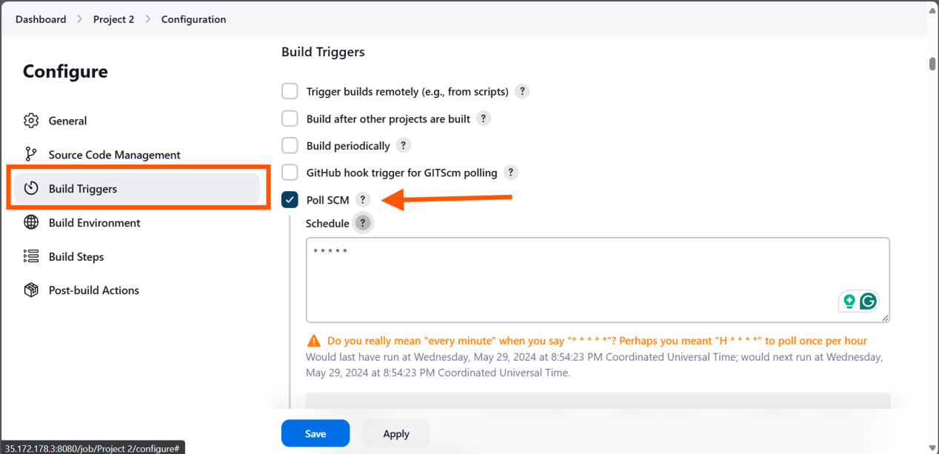

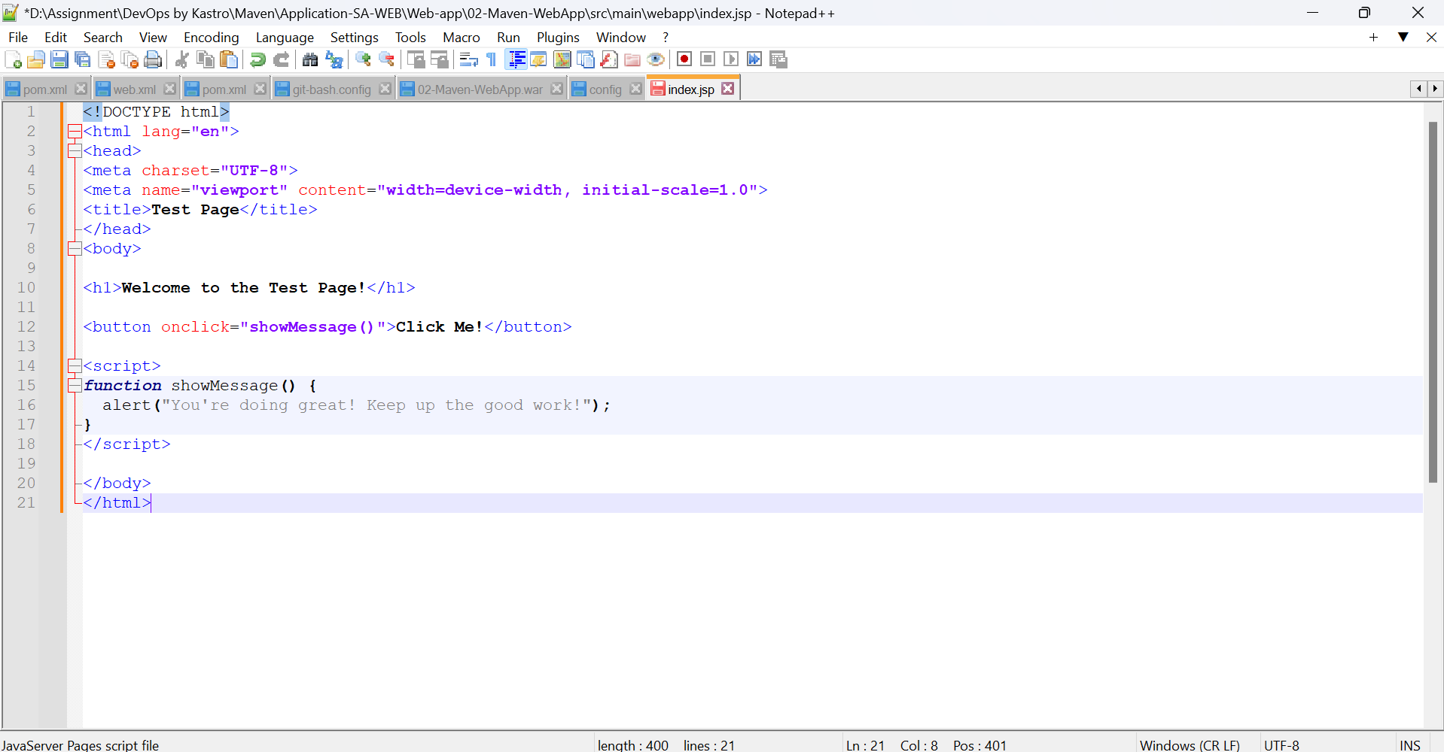

Change on Index.html from local system

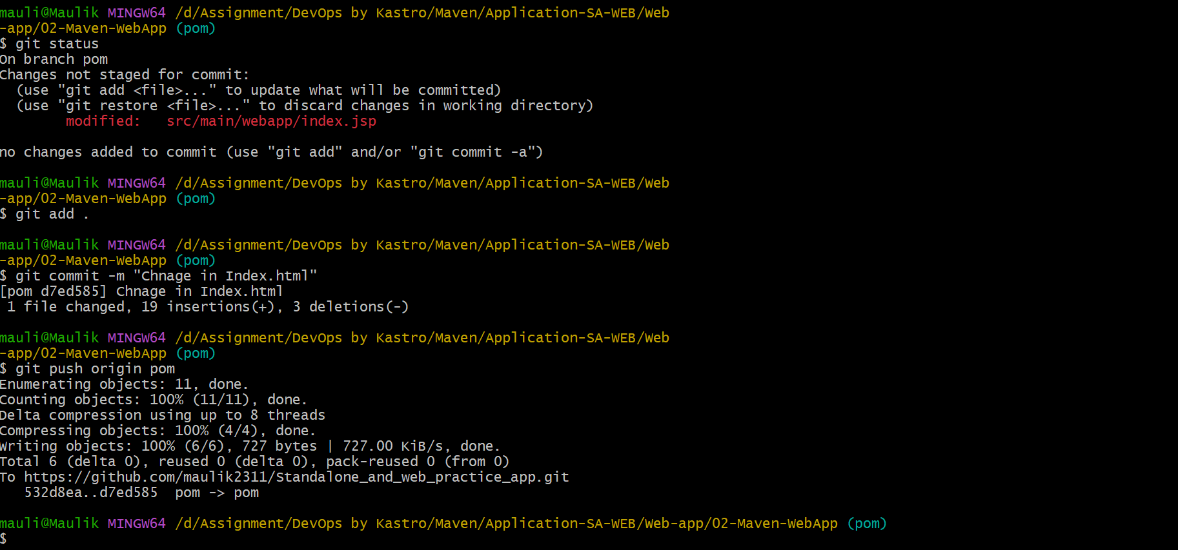

Automatically build and deploy on Tom-Cat we server:

